SAFE SMILE PRESS RELEASE TEMPLATE
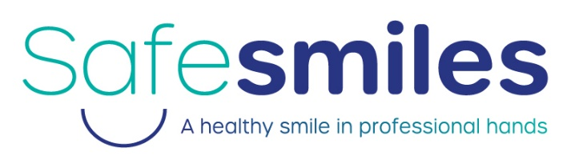
[INSERT NAME OF ORGANISATION] backs new campaign championing the benefits of safe dentistry
INSERT NAME OF ORGANISATION | INSERT DATE
[INSERT NAME OF ORGANISATION] is supporting a new charity campaign helping people to make safer choices when it comes to improving the appearance of their smile.
Safe Smiles is an initiative by the Oral Health Foundation and is raising awareness about the benefits of safe dentistry when treatment is carried out in dental practices by trained professionals.
The new campaign has been announced following growing concerns about direct-to-consumer alternatives, and a worrying number of people performing their own dental treatments at home.
Research by the Oral Health Foundation reveals one-in-four (25%) UK households have opted for some form of DIY dentistry during the pandemic. ¹
[INSERT NAME OF SPOKESPERSON], [INSERT JOB TITLE] at [INSERT NAME OF ORGANISATION], is alarmed by the findings and believes those attempting their own dental fixes risk serious and lasting damage to the health of their mouth.
[INSERT NAME OF SPOKESPERSON] says: “Any kind of dental treatment is extremely complex and needs expert hands to be carried out safely and effectively. Please do not attempt your own dental treatment at home, no matter how simple you believe it might be. Those who do run the risk of putting the health of their mouth in severe danger, leading to long-term or permanent damage.
“Injuries to the teeth, gums, tongue and lips are all common occurrences when dentistry is carried out away from the dental practice. It can result in speaking difficulties, could make eating and drinking harder, and even cause problems for your breathing.”
Further findings by the Oral Health Foundation shows that over half (55%) of UK adults feel they have neglected their teeth during lockdown. Around one-in-seven (15%) admit to not brushing their teeth as much as before the pandemic. One-in-five (20%) are eating unhealthier foods, and more than one-in-ten (11%) have been drinking more alcohol. ¹
Dr Nigel Carter, Chief Executive of the Oral Health Foundation is worried this could lead to many people experiencing oral diseases, like tooth decay.
Dr Carter says: “We are really concerned by evidence suggesting the UK’s oral health habits have declined during the pandemic. Symptoms associated with dental disease – mainly pain and changes in visual appearance – are leading to people seeking quick and cheap home cosmetic treatments advertised online. This is a great cause for concern and one of the key driving forces behind Safe Smiles.
“When carried out correctly, dental treatment can give you the white, straight and confident smile you have always dreamed about. This must involve face-to-face contact with a trained dental professional inside the dental practice. The Safe Smiles campaign is all about giving you the very best advice about the safest and most effective way to have dental treatment.”
Safe Smiles tackles some of the most common and dangers dental procedures attempted at home. This includes tooth whitening and orthodontic treatment.
The campaign also warns against dental tourism and poorly fitted mouthguards, as well as harmful cosmetics mouth like lip tattoos, oral piercings, tooth jewellery, jaw modifications and grillz.
The new campaign is being supported by Align Technology and has gathered support from some of the UK’s largest dental associations. Safe Smiles has already received backing from the British Dental Industry Association, British Academy of Cosmetic Dentistry, British Dental Bleaching Society, British Society of Dental Hygiene and Therapy, British Association of Dental Nurses, and British Association of Dental Therapists.
You can learn more about Safe Smiles and how to have dental treatment done safely at www.dentalhealth.org/safesmiles.
Ends
- ORAL HEALTH FOUNDATION (2020) ‘ Oral health UK adult survey’, UK, 2,004 sample.

