**ALL SMILES FOR**

**[NAME OF DISTRICT/TOWN/CITY/PRACTICE]**

PRESS RELEASE | **[DATE]**

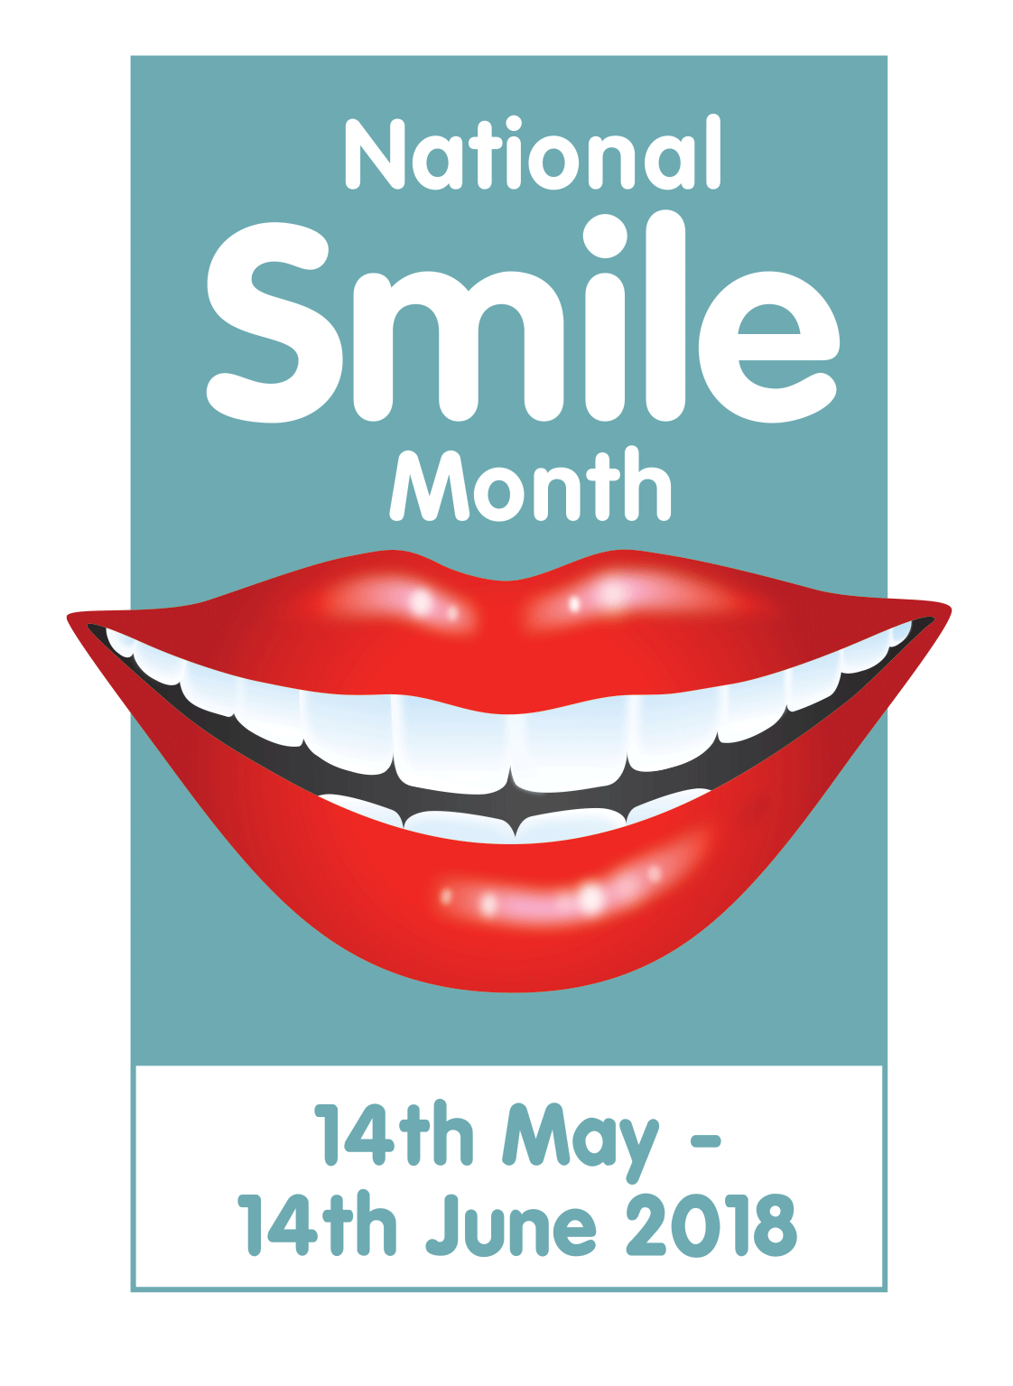

**National Smile Month is coming to [town/district], as [name of your organisation] will be holding a special event to back the UK’s biggest oral health campaign.**

Taking place from 14 May to 14 June, National Smile Month aims to promote and raise awareness of good oral health, and ***[name of your organisation]*** is getting involved in doing just that.

***TOP TIP – Insert a paragraph containing all the information needed – remember the 5 W’s – who, what, where, when, why! Here’s an example:***

*To show their support, the team from Smile Clinic in Oxdown will be holding an open day on 30 May from 10am that aims to put the smile into National Smile Month. Anyone who wants to pop along will receive their very own goody bag and get their picture taken with a Smiley – the campaign icon.*

***TOP TIP – Add a quote from the chief organiser/head of your organisation. If you are struggling for inspiration, here’s one we made earlier:***

Dr Face from Smile Clinic said: “We love taking part in National Smile Month. That is why we are having an open day. If you are a patient or simply want to talk to a member of staff about your oral health, pop down. It’s going to be a lot of fun!

“Good oral health is vital for a healthy smile as well as a healthy body, and we’ll be spreading that message at our open day.”

***Here’s a quote you can pop in from us!...***

Chief Executive of the Oral Health Foundation, Dr Nigel Carter OBE said: “I’m delighted that ***[name of your organisation]*** has joined the thousands of organisations in engaging with National Smile Month. It is a great reflection of local community spirit and an excellent way to promote good oral health.

“By making an event as fun and imaginative as possible, we hope it will inspire more people to join in the fun than ever before while delivering the Oral Health Foundation’s three key messages for good oral health; brush your teeth last thing at night and at one other time during the day with a fluoride toothpaste, cut down on sugary foods and drinks and visit the dentist regularly, as often as they recommend.”

For more information please visit [www.smilemonth.org](http://www.smilemonth.org)

**- - - ENDS - -**